Dear Andrey and Olga

I was delighted to receive your email, which I have read several times.

The reason for not responding is that I have been exceptionally busy teaching as well as operating. I have recently been to the Italian Aesthetic meeting in Florence, the Korean meeting in Seoul and a course on the Face in New Zealand. In addition, I am preparing for the next MAFAC course to be conducted in the United States with the American Society of Aesthetic Plastic Surgeons meeting in San Diego in one weeks’ time. At each of these meetings I continue to teach what you first experienced in St Petersburg in 2011. I am delighted to know that my presentation at this meeting was effective in stimulating you to come all the way to Melbourne for the 2011 course.

I remember you both well from that meeting.
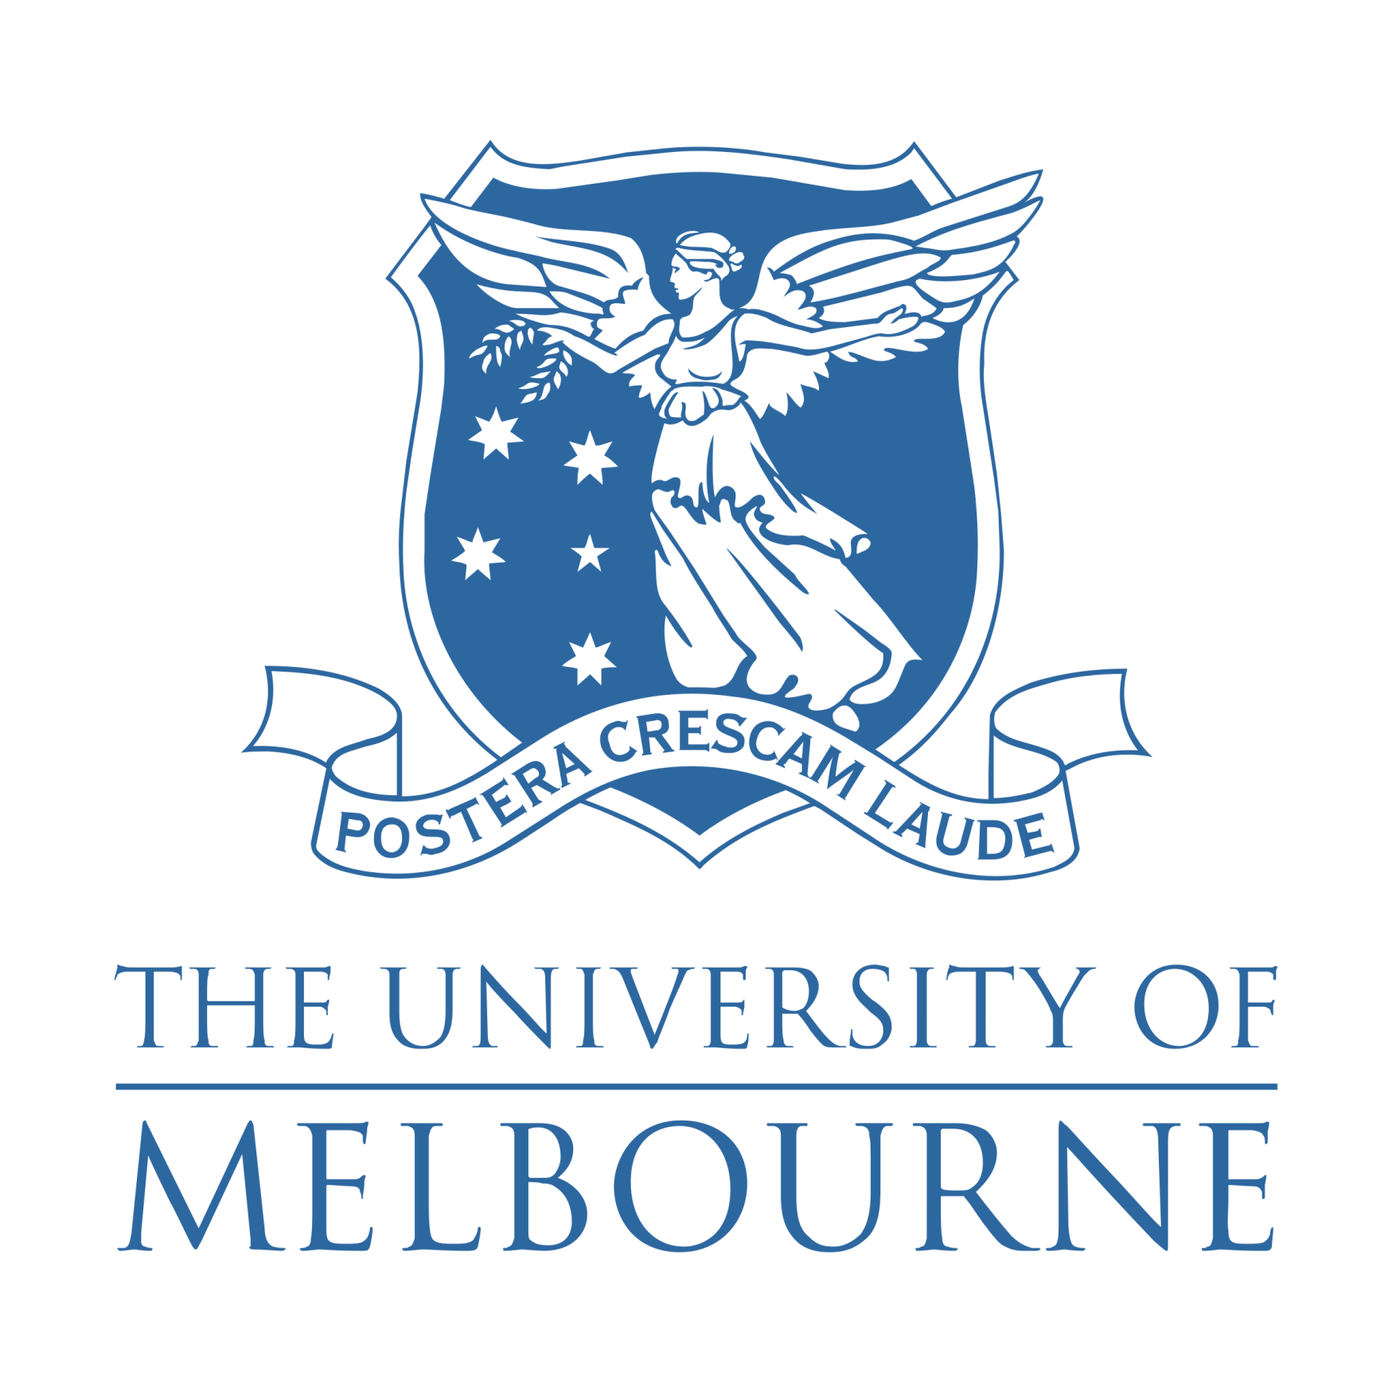
I am pleased that this has all resulted in significant success for your practice and that you have been able to promote ‘spacelifting’, which is a clever way of differentiating the modern correct anatomical approach using spaces, from the traditional SMAS and subcutaneous type procedures. In fact, I specifically mentioned spacelifting at the meeting in Korea, as I thought they would like to have some more modern touch to facelifting! As so often happens, a teacher learns from his bright students who continue on with the teaching and applies this to a different level and so I am very happy, having you in Moscow, as I have colleagues in other parts of the world, performing Complete Composite Facelifts, as is their anatomical name, but Spacelift is the nickname, thanks to you.

Of course, we would be delighted to take care of patients directed by yourselves to our clinic in Melbourne. The details for adding to your website are; info@bmendelson.com.au. In addition, it would be nice to know that patients have come referred by yourselves so you could also mention this as well. Having links of course is beneficial to our websites.

I am wondering, on a separate aspect, whether you and Andrey are teaching other plastic surgeons. This is happening in many places around the world, where surgeons who, having learnt the technique and refined it, become very good teachers because they have learnt how to make the transition from their previous procedure, which they were comfortable with, although wanting more of a result, that is why are often the best teachers. If Andrey is interested in having visiting surgeons attend his operating, we call this a Facelift Observership. Soon, we will be adding a list of surgeons around the world who are interested in accepting visitors. Obviously, coming all the way to Melbourne to learn is unrealistic and should not be necessary given the experience of the people who have done the Course and seen the logic of applying the anatomy. With my kindest regards.

Yours sincerely
Dr. Bryan Mendelson

